**Converting Date format from DD/MM/YYYY to MM/DD/YYY in Excel**

1. Select the column that you want to format

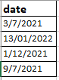

1. Go to Data 🡪Text to Columns
2. Text to Columns will appear. Leave that as it is and hit next

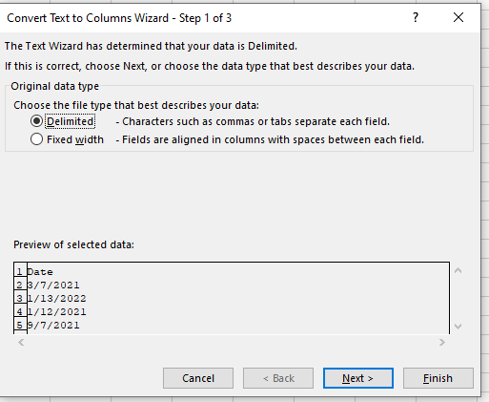

1. Unselect all the delimiters. Hit next

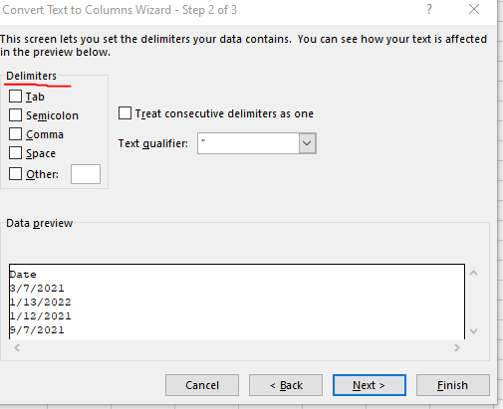

1. in “Column data format” select Date option with “**DMY**” and click Finish
2. Date column is now formatted to “MM/DD/YYYY”

